**Plant Recognition using Convolution Neural Network**

**1 Problem Statement**

Plants are the backbone of life on earth, as it provides us food and oxygen. Hence, A good understanding of plants is needed to help in identifying new or rare plant species. Such identification will in turn improve the drug industry, balance the ecosystem as well as the agricultural productivity and sustainability. Botanists are interested in the variations on leaf characteristics as it helps them to carry out a comparative analysis on plants. Recognition of Plant from images is a challenging computer vision task. The various types of challenges are many parts of the plant, which need to be identified, are also diverse in nature with high intra class variations and small inter class variations. Although the research on automatic plant taxonomy has produced fruitful results, but those models are still far from the requirements of a fully automated ecological surveillance scenario. The traditional classification models rely heavily on preprocessing to eliminate complex background and suffer from problems like vanishing gradient and degradation. Hence, it is important to propose an approach that will overcome the pitfalls of the state-of-the-art methods.

**2 Background Work**

As the machine learning technology advances, sophisticated models have been proposed for automatic plant identification. With the popularity of smart phones and the emergence of Pl@ntNet mobile app, millions of plant photos have been acquired. Mobile based automatic plant identification is essential to real-world social-based ecological surveillance. Nowadays, many efforts have been conducted in extracting local characteristics of leaf, flower, or fruit. Most researchers use variations on leaf characteristic as a comparative tool for studying plants, and some leaf datasets including Swedish leaf dataset, Flavia dataset, and ICL dataset are standard benchmark.

Some of the researches extracted shape characteristics and moment features of the leaves and analyzed 15 different Swedish tree classes using back propagation for the feed-forward neural network. Others chose the local contrast and other parameters to describe the characteristics of the surrounding pixels of veins. The artificial neural network was used to segment the veins and other leaves. Other research proposed an efficient leaf vein extraction method by combining snakes technique with cellular neural networks, which obtained satisfactory results on leaf segmentation. It used the probabilistic neural network as a classifier to identify the plant leaf images, which has a better identification accuracy compared to back propagation neural network. In 2013, the idea of natural-based leaf recognition was proposed, and the method of contour segmentation algorithm based on polygon leaf model was used to obtain contour image.

**3 Materials and Methodology**

Figure 1 shows the work flow that can be used in this work.

**3.1 Dataset**

**3.1.1 Data Collection and Dataset Preparation**: The BJFU100 dataset which consists of 100 species of ornamental plants in Beijing Forestry University campus, can be used in this work.

**3.2 Methods**

**3.2.1 Training:** Plant recognition model built by ResNet will be trained by the stochastic gradient descent (SGD) algorithm with the categorical cross entropy loss function as optimization objective.

**3.2.2 Evaluation Measures**: Measures such as accuracy, precision will be computed for evaluating the performance of the classifier.

**3.2.3 Deployment and analysis on real life scenario:** The trained and tested plant recognition model will be deployed in a real-life scenario.

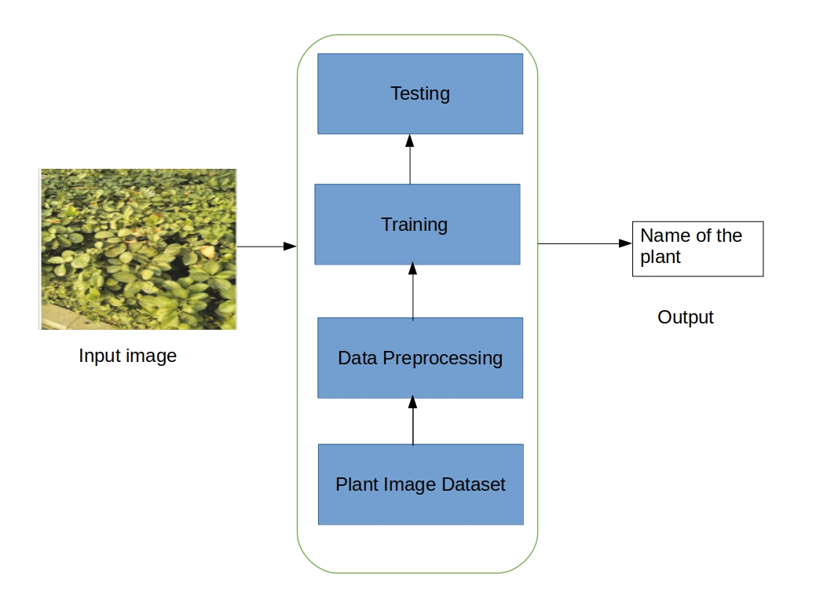

Figure 1: Architecture of plant recognition system

**4 Experimental Design**

**4.1 Software and Hardware Requirements**: Pythonprogramming language anddeep learning library keras ,16 GB ofRAM, and NVIDIA GTX 1070 GPU 8 GB is used for training.